## CHANDIGARH UNIVERSITY

## UNIVERSITY INSTITUTE OF NGINEERING

**DEPARTMENT OF COMPUTER SCIENCE & ENGINEERING**



|  |  |
| --- | --- |
| **Submitted By: Submitted To:**  Vivek Kumar(21BCS8129) Er. Himanshi (13362) | |
| **Subject Name** | Web and Mobile Security Lab |
| **Subject Code** | 20CSP-338 |
| **Branch** | Computer Science and Engineering |
| **Semester** | 5th |

**Experiment - 2**

**Student Name: Vivek Kumar UID: 21BCS8129**

**Branch: BE-CSE(LEET) Section/Group: WM-20BCS-616/A**

**Semester: 5th Date of Performance: 19/08/2022**

**Subject Name: Web and Mobile Security Lab Subject Code: 20CSP-338**

**1. Aim/Overview of the practical:**

Design a method to simulate the HTML injection and cross-site scripting to exploit

the attacker.

**2. Task to be done/ Which logistics used:**

Analyse the HTML injection.

**3. Requirements (For programming-based labs):**

PC with Windows 7 or above.

**4. Result/Output/Writing Summary:**  
 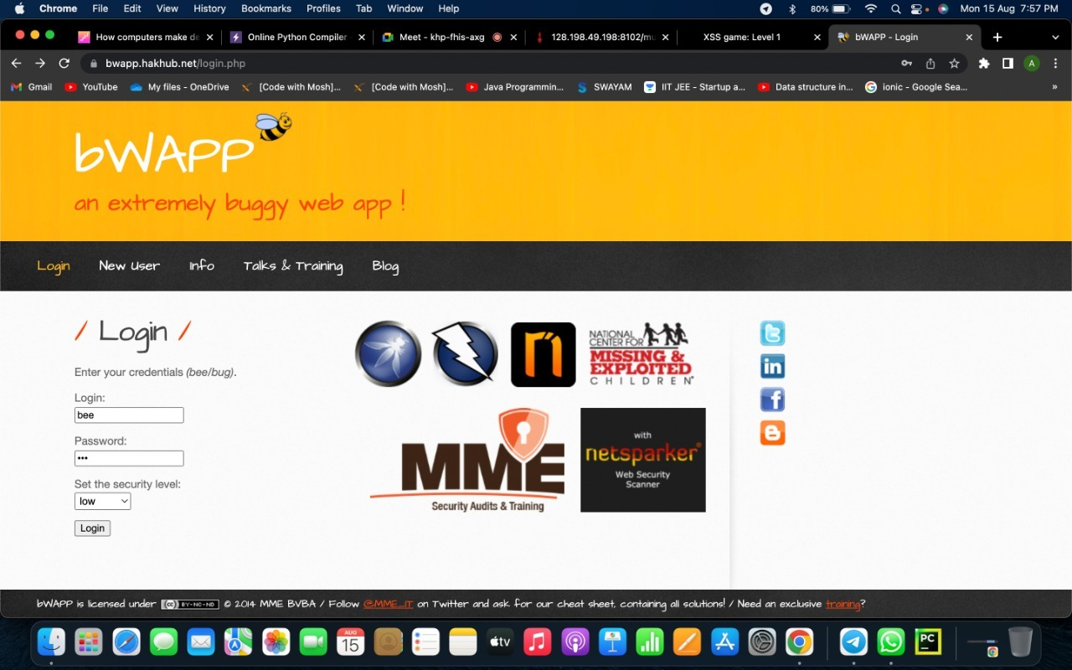

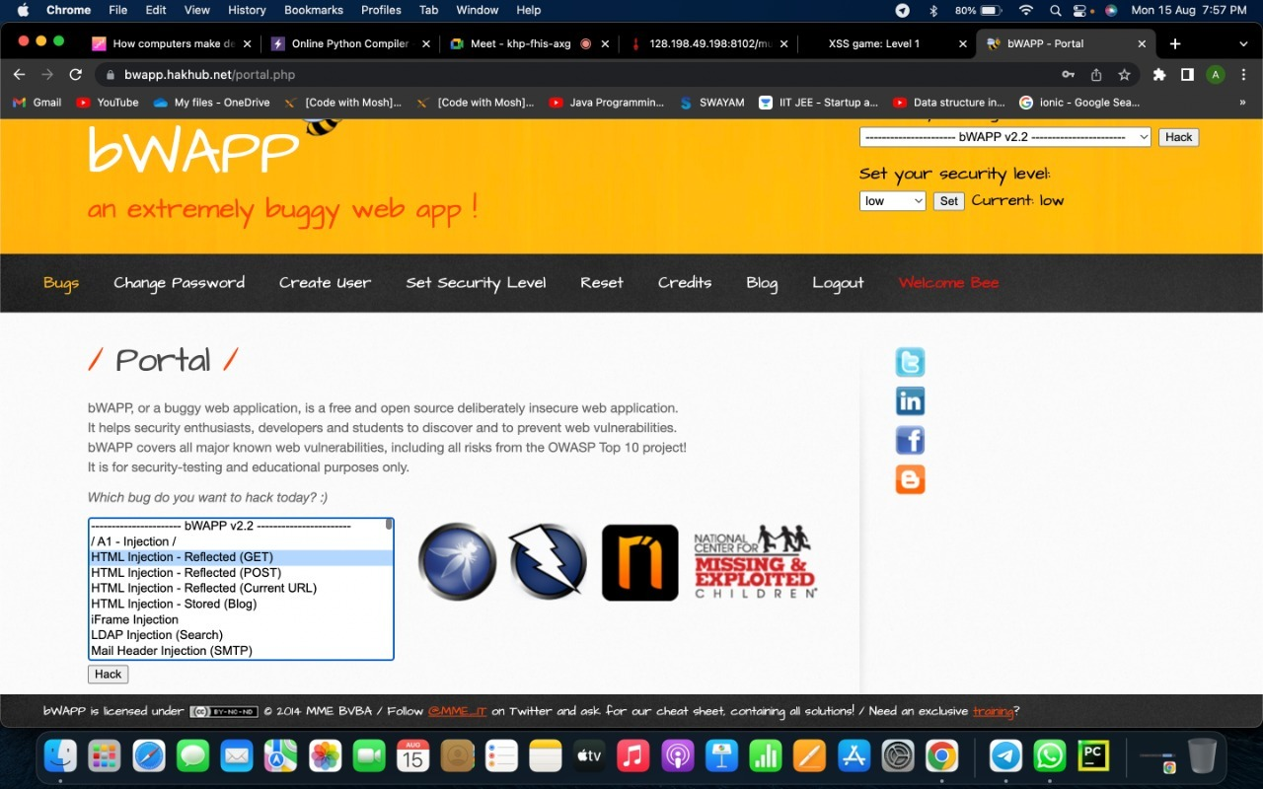

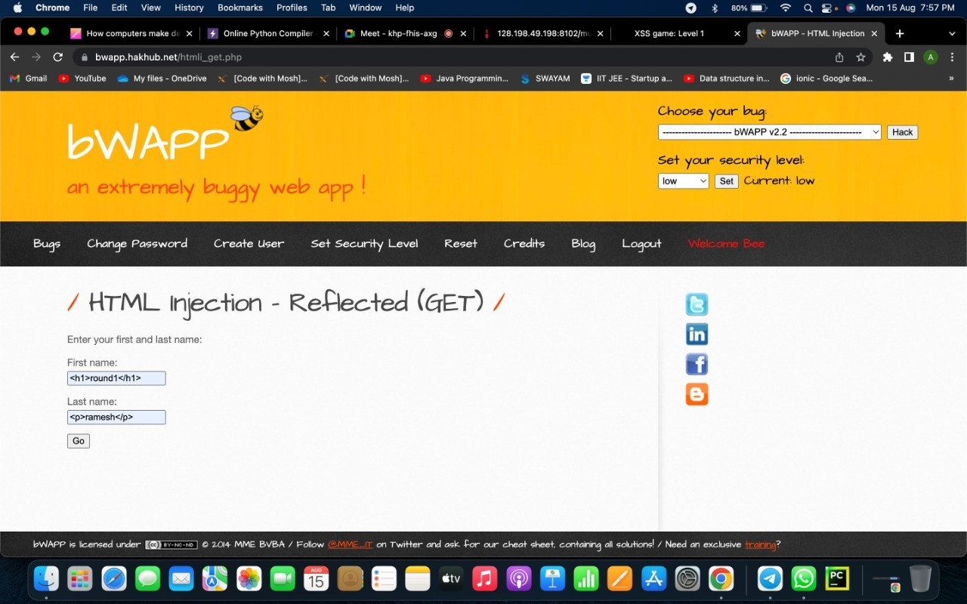

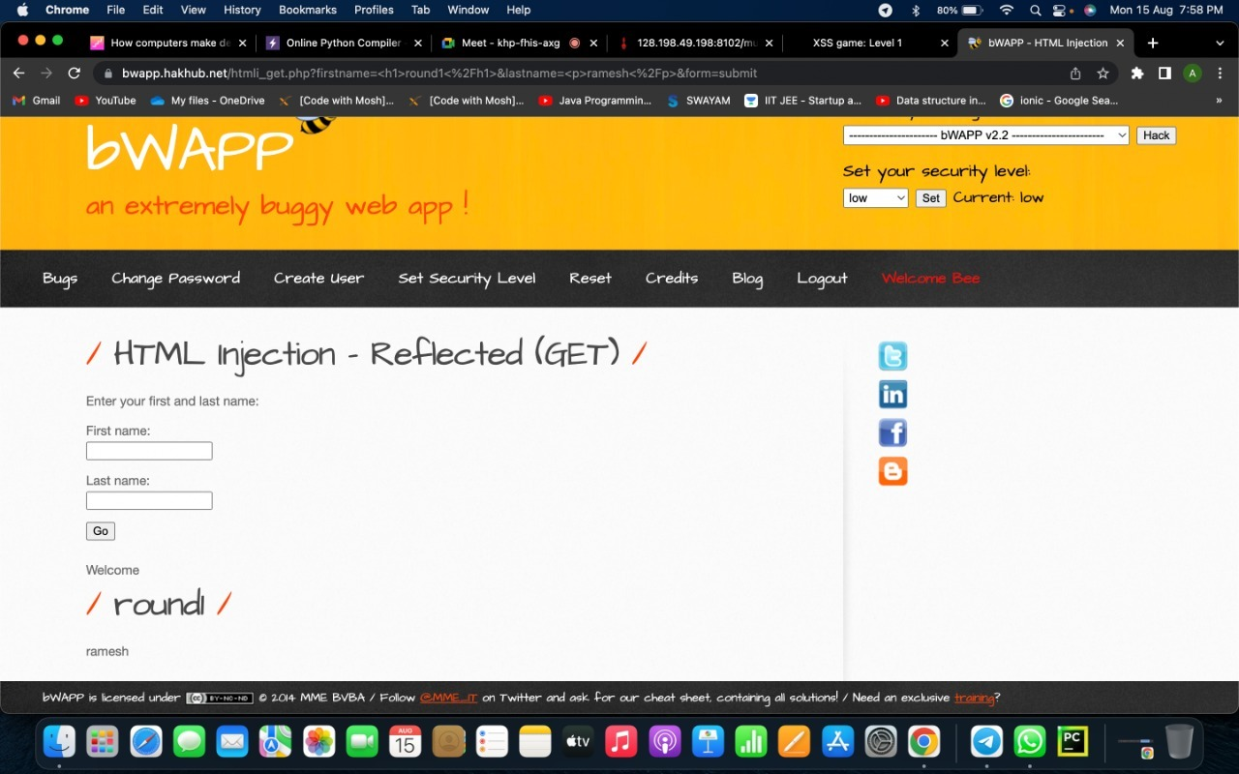

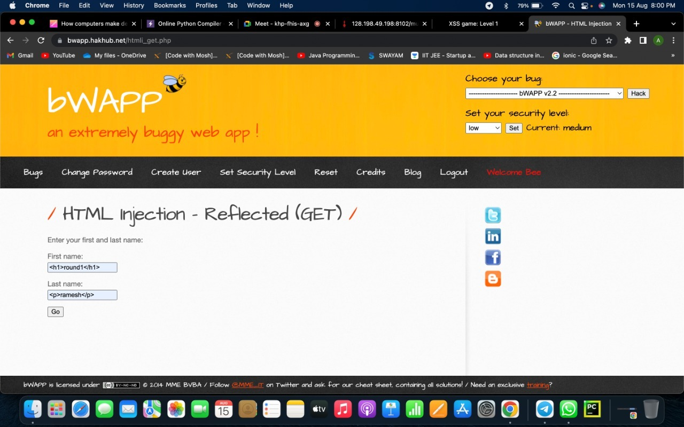

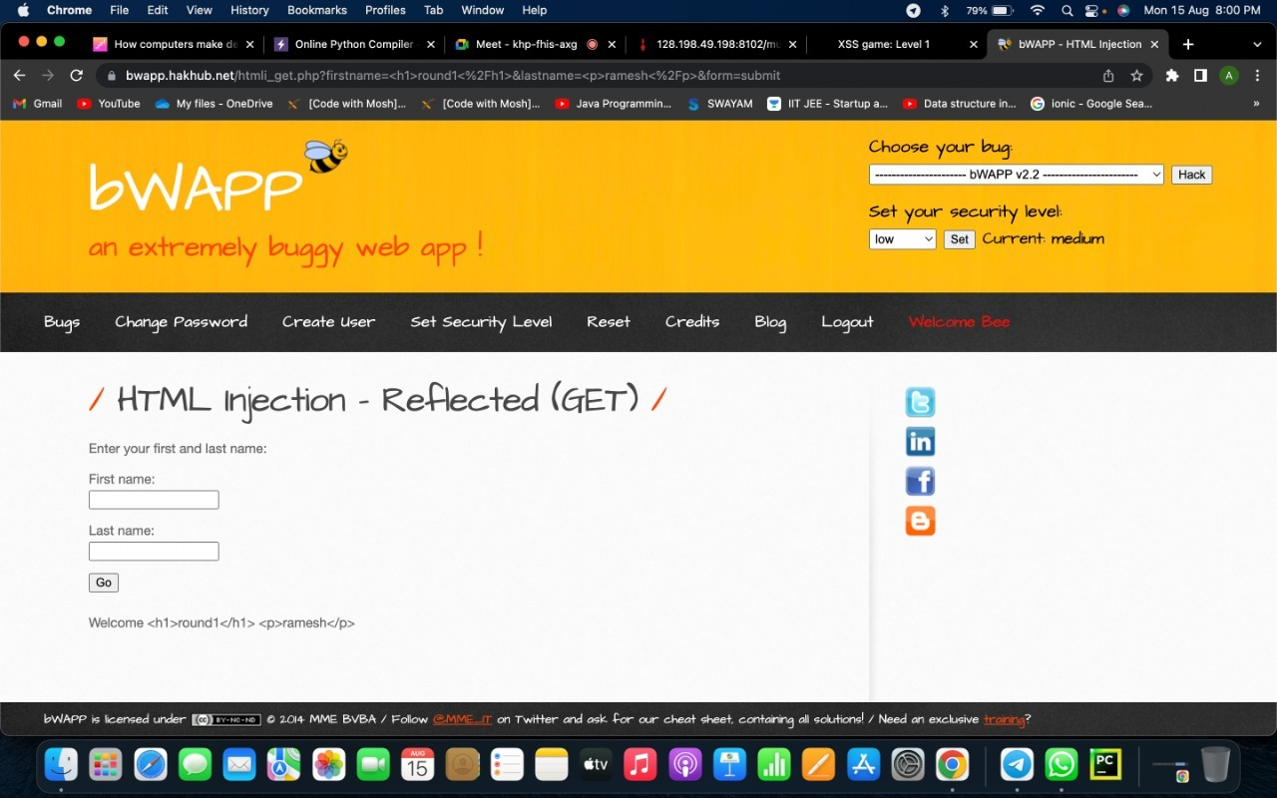

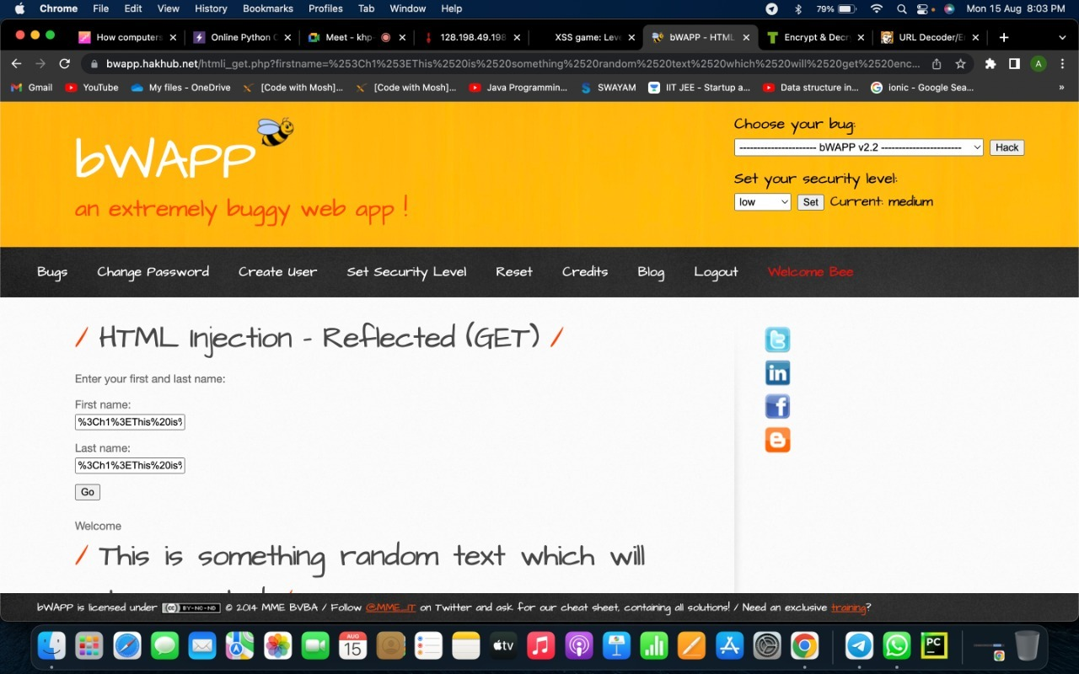

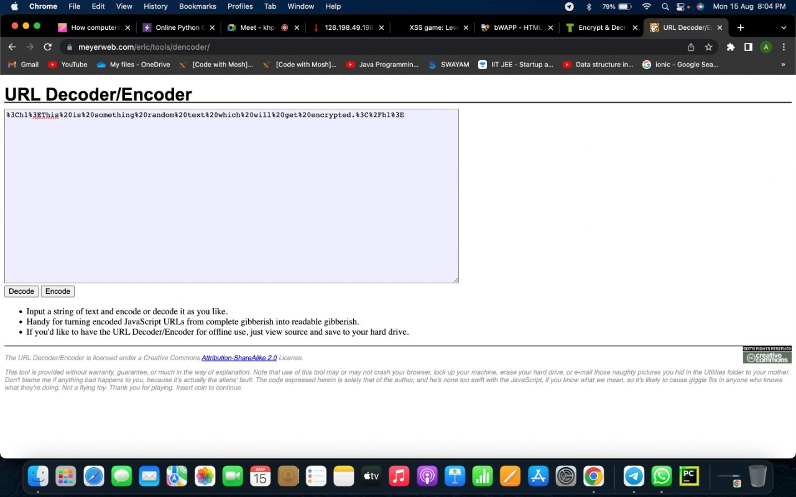

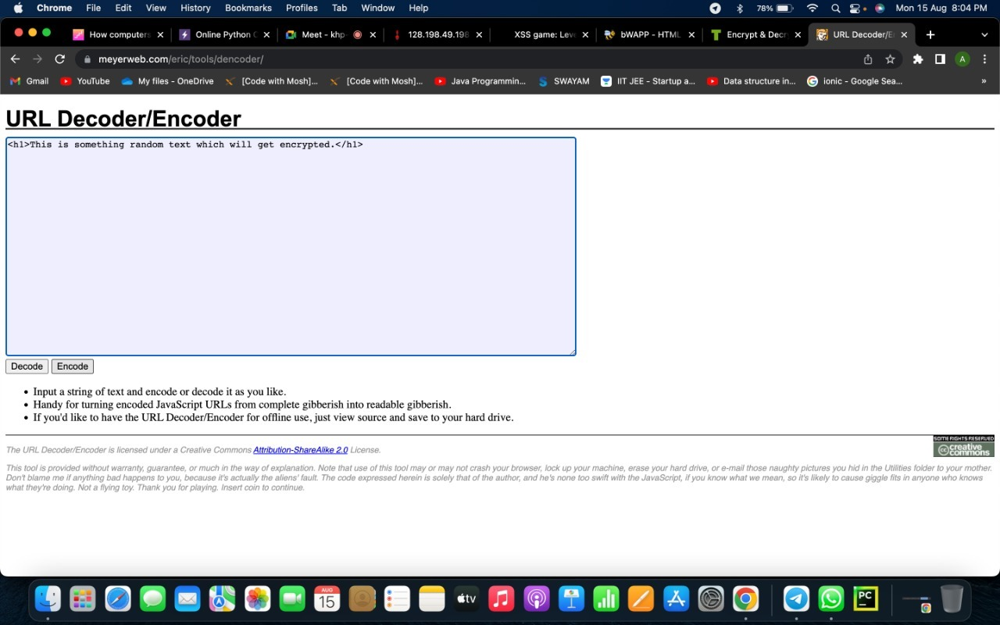

**5. Observations/Discussions/ Complexity Analysis:**

In this Experiment we have learn about the HTML injection and XSS injection how it works on our network and websites.

**Learning outcomes (What I have learnt):**

1. Learned what HTML injection
2. Learned how these attacks are constructed and applied to real system.
3. Learned about security level and HTML injection at each level.

**Evaluation Grid (To be created per the faculty's SOP and Assessment guidelines):**

|  |  |  |  |
| --- | --- | --- | --- |
| Sr. No. | Parameters | Marks Obtained | Maximum Marks |
| 1. | Worksheet completion including writing learning objectives/Outcomes.  (To be submitted at the end of the day). |  |  |
| 2. | Post-Lab Quiz Result. |  |  |
| 3. | Student Engagement in  Simulation/Demonstration/Performance and Controls/Pre-Lab Questions. |  |  |
|  | Signature of Faculty (with Date): | Total Marks Obtained: |  |